**Lineysha Consulting assessment (News update & redux store app)**

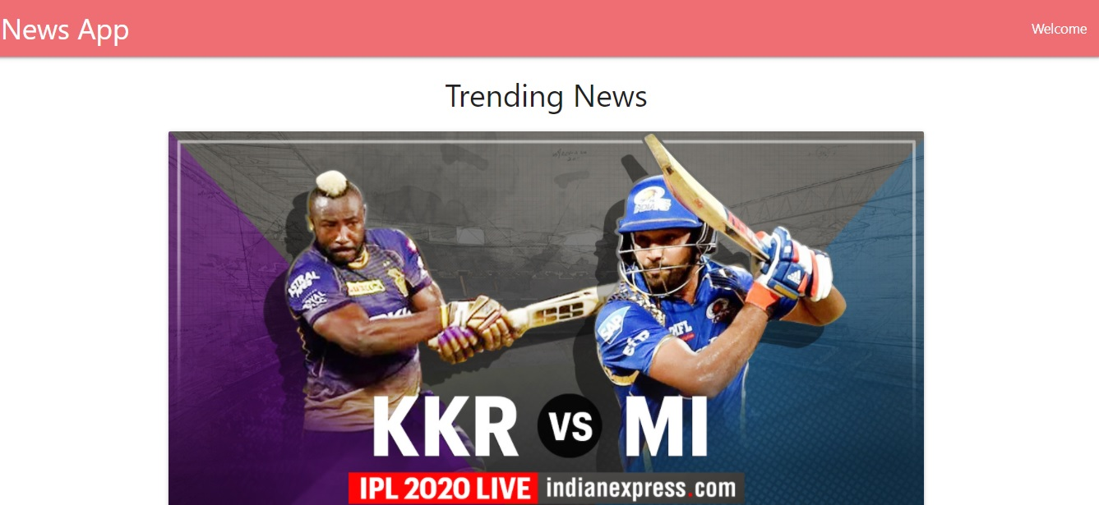

^ Developed ui components with the help of materialize css online library

^With the help of axios library called api to fetch data and filled the intital array as empty and filled that array with the help of componentdidmount method and then inserted value into empty array that I created

^while loading data initial state is set to no post by checking the string length if it is true array values is shown by passing it as prop inside component by using map method to itrate data

^with the help of slice method limited to less number of data/array

^Technology used: reactjs, nodejs, materialize, axios

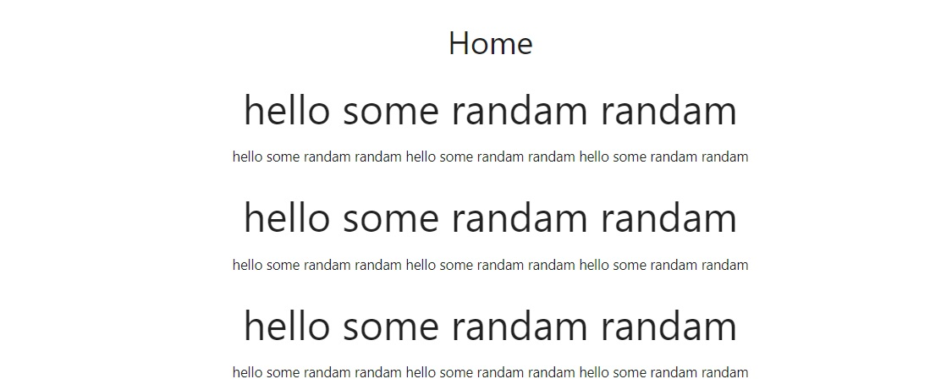

^created store to use redux where I initiated array of elements from root reducers which is held inside reducers folder

^inside reducer folder state is defined initially

^finally the store values is passed to home page to view it as props

^default action is passed to show inside to show which are stored inside the store

^Technology : Reactjs and redux